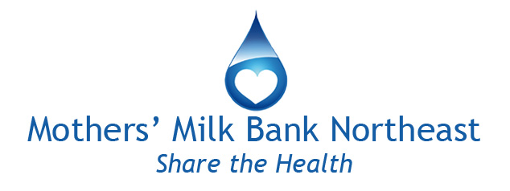
Bereaved Mothers and Milk Donation
Information for Health Professionals

Thank you for the important work you do supporting grieving mothers. Here are some common questions professionals have about the process of milk donation.

What is Mothers’ Milk Bank Northeast?

Mothers’ Milk Bank Northeast is a nonprofit community milk bank operating under the guidelines of the Human Milk Banking Association of North America (HMBANA). We provide safe, pasteurized donor human milk to hospitals and families throughout the Northeastern United States. Donor milk can save the lives of premature and critically ill infants.

Why would a bereaved mother donate milk?

Some lactating mothers choose to donate expressed milk following the loss of a child as a way of processing their grief. While this option is not right for everyone, many mothers find comfort knowing that their baby’s milk will help other frail and premature babies.

Should our stillbirth team include a lactation consultant?

Yes. A lactation consultant can help the mother to understand what is happening to her body and inform her of the ways she can slow and stop her milk supply. Throughout pregnancy, the body prepares for breastfeeding after birth. Delivery of the baby and the placenta trigger the body to begin producing milk to feed the baby; the body does not “know” that the baby has died, and begins to produce milk. Some mothers will want to express some milk as a way to ease the physical and emotional pain of milk coming in after a loss.

When premature babies die after a few weeks, mothers sometimes have a large supply of milk. Can mothers donate this milk?

Mothers work hard to pump milk for their premature babies. When the baby dies, the milk is often an important connection to the baby. Throwing it away is very painful, and for some mothers unthinkable. Milk banks gratefully accept donations of milk from bereaved families after the baby has died.

We have a bereaved mom who would like to donate her milk. How do we begin?

Thank you for your efforts on behalf of your bereaved mothers. To begin the screening process, we must hear from the mother herself, by either phone (617-527-6263 x3) or email (donate@milkbankne.org). We are happy to provide any information to the hospital team or family members to share with the mother, but we cannot begin the screening process until the mother has contacted us directly. Nonprofit milk banks follow this guideline to ensure that no mother feels pressure to donate.

What is the donor screening process?

The donor screening process is described in some detail at www.milkbankne.org/donate.
Briefly, the screening process has 3 steps:

- A 10-15 minute phone screen asking basic health questions
- A packet of information for donors and forms to return to the milk bank: a detailed health form, consent to donate, consent to contact donor’s healthcare provider for basic health information
- A blood test

Once the mother completes these steps successfully she can send us her milk.

How can we support mothers through the screening and donation process?

There are several ways that medical teams can support bereaved mothers through the donation process:

- If possible and appropriate, please discuss milk donation before the baby has passed away. This can be painful, and is not always appropriate, but it can also be comforting for parents grappling with making sense of the imminent loss of their baby. It also allows the possibility of mothers beginning the screening process early, before the shock of the death.
- Mothers in the throes of such a terrible loss may need your gentle assistance in filling out some of the forms. You can also facilitate drawing the mother’s blood in your hospital or physician’s office and arranging for FedEx to pick it up for delivery to the Rhode Island Blood Center for testing. Blood does not need to be spun. The milk bank provides the blood kit (vials, requisition, and FedEx bag and label.)
- If some of mother’s milk is still in the hospital freezers, we can send shipping boxes to you to ship it to us directly. We will send the donor mother boxes for whatever milk she may have a home.

What if a mom has been given medications for the birth or afterward? Can she still donate?

This depends on the medication and on how long she took it. It is possible that mothers will not be able to donate due to medications. Our protocols are designed for the safety of very premature and fragile babies. However, some medications are acceptable, and some require only a temporary deferral. Please call our Donor Intake Coordinators (617-527-6263 x3) with specific questions. If the mother is disqualified from donating milk for any reason, we can facilitate giving her milk to researchers who are conducting non-commercial research to advance our knowledge of human milk.

Is there a minimum amount of milk a mother must donate?

There is no minimum for bereaved mothers. Some bereaved mothers donate only what they have already pumped, and others continue to donate for a period of time after the loss of their babies.

Do you have materials we can share with mothers on milk donation?

Yes. We have a simple rack card especially for bereaved mothers. To order free copies for distributing in your practice, contact Ann Marie Lindquist, Director of Community Relations, annmarie@milkbankne.org, 617-527-6263 x2.

8/13/21
www.milkbankne.org 617.527.6263 donate@milkbankne.org

